*Project Charter*

*Ezrecipies.com*

*Bellarmine University E-Commerce*

*2/3/2017*

*Brooke Kennedy*

*Sam Fitzgerald*

*Carson Blevins*

Contents

1. Project Description……………………………………………………. 3
2. Project Purpose…………………………………………………………3
3. Business Case…………………………………………………………..3
4. Project Deliverables…………………………………………………….3
5. Project Milestones………………………………………………………3
6. Project Roles and Responsibilities……………………………………...3
7. Project Life Cycle Methodology and Tools…………………………….3
8. Production Fees and total Cost………………………………………….4
9. Project Description

The project is to setup a site to allow customers to search for or load recipes, allowing for the automatic option to buy the needed ingredients. We will look into using a recipe API to achieve our site’s purpose. We will also provide a way to customize the search for recipes and ingredients so that users can give preference to things such as nutrition and time.

1. Project Purpose

The purpose of the project is to provide a platform so users can easily access food and ingredients to allow users to cook the meals they want.

1. Business Case

People are always looking for the easiest and most convenient way of doing tasks. Our platform will eliminate the need of searching for specific ingredients in multiple locations, allowing for a convenient way to successfully try new recipes, and sort by user preferences.

1. Project Deliverables

The focus is on developing and implementing a site that utilizes amazon.com and a recipe database to provide recipes and their respective ingredients. We will be creating software to scrape data and interact with these websites, along with creating the infrastructure so that users can customize their searches through our site.

1. Project Milestones

Phases:

1. API implementation and testing.
2. Establish site – Build the site.
3. Integrate software – Combine steps 1 and 2.
4. Testing and Debugging – Test the site for possible problems.
5. Add more features – Add new features to the site that allows for search customization (nutrition/time/etc.).
6. Testing and Debugging – Retest the site with the new features.
7. Deploy
8. Project Roles and Responsibilities

Brooke Kennedy

Carson Blevins

Sam Fitzgerald

1. Project Life Cycle Methodology and Tools

We will use the Agile Methodology which will allow us to complete our project in weekly phases. This approach will allow for unexpected changes we incur along the way and provide adaptability.

1. Production Fees and total Cost

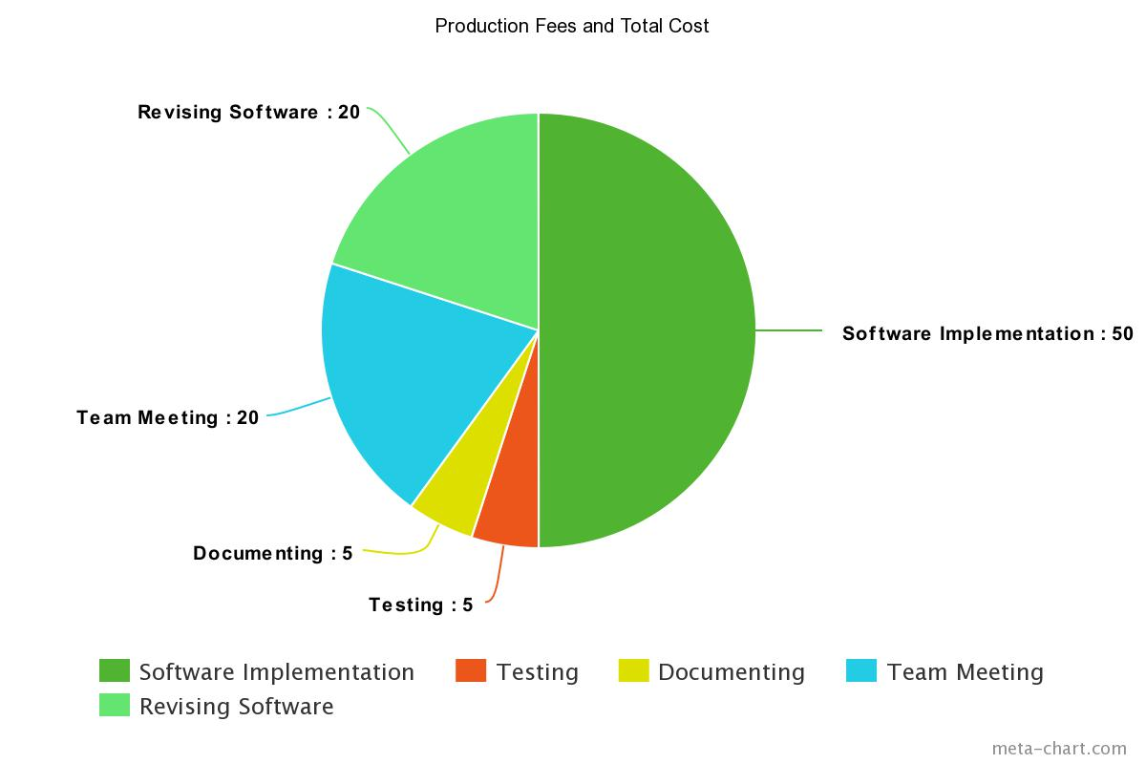

|  |  |  |  |
| --- | --- | --- | --- |
| Labor | Hours | Rate | Total |
|  | 60 | $90/hour | $16,200 |
| Web Server |  | $100 | $100 |
| Total |  |  | $16,300 |